Name: Somnath R. Shintre Roll No:

Class: TE CSE Batch:

**Title: -** Write a GUI based program to create a student registration and Login. Store Registration data in Database and take Login information from Database.

**Program: - Registration GUI**

import javax.swing.*;  
import java.awt.*;  
import java.awt.event.*;  
import java.sql.*;  
import javax.swing.border.*;  
  
public class JDBC_GUI_Registration extends JFrame implements ActionListener  
{  
 private JLabel lblNewUserRegister;  
 private JFrame jf;  
 private JPanel contentPane;  
 private JTextField firstname;  
 private JTextField lastname;  
 private JTextField email;  
 private JTextField username;  
 private JTextField mob;  
 private JPasswordField passwordField;  
 private JButton btnNewButton1;  
 private JButton btnNewButton2;  
   
 JDBC_GUI_Registration(){  
   
 setDefaultCloseOperation(JFrame.EXIT_ON_CLOSE);  
 setBounds(450, 190, 1014, 597);  
 setResizable(false);  
 setTitle("Registration Form");  
 contentPane = new JPanel();  
 contentPane.setBorder(new EmptyBorder(5, 5, 5, 5));  
 setContentPane(contentPane);  
 contentPane.setLayout(null);  
  
 lblNewUserRegister = new JLabel("New User Register");  
 lblNewUserRegister.setFont(new Font("Times New Roman", Font.PLAIN, 42));  
 lblNewUserRegister.setBounds(362, 52, 325, 50);  
 contentPane.add(lblNewUserRegister);  
  
 JLabel lblName = new JLabel("First name");  
 lblName.setFont(new Font("Tahoma", Font.PLAIN, 20));  
 lblName.setBounds(58, 152, 99, 43);  
 contentPane.add(lblName);  
  
 JLabel lblNewLabel = new JLabel("Last name");  
 lblNewLabel.setFont(new Font("Tahoma", Font.PLAIN, 20));  
 lblNewLabel.setBounds(58, 243, 110, 29);  
 contentPane.add(lblNewLabel);  
  
 JLabel lblEmailAddress = new JLabel("Email\r\n address");  
 lblEmailAddress.setFont(new Font("Tahoma", Font.PLAIN, 20));  
 lblEmailAddress.setBounds(58, 324, 124, 36);  
 contentPane.add(lblEmailAddress);  
  
 firstname = new JTextField();  
 firstname.setFont(new Font("Tahoma", Font.PLAIN, 32));  
 firstname.setBounds(214, 151, 228, 50);  
 contentPane.add(firstname);  
 firstname.setColumns(10);  
  
 lastname = new JTextField();  
 lastname.setFont(new Font("Tahoma", Font.PLAIN, 32));  
 lastname.setBounds(214, 235, 228, 50);  
 contentPane.add(lastname);  
 lastname.setColumns(10);  
  
 email = new JTextField();  
 email.setFont(new Font("Tahoma", Font.PLAIN, 32));  
 email.setBounds(214, 320, 228, 50);  
 contentPane.add(email);  
 email.setColumns(10);  
  
 username = new JTextField();  
 username.setFont(new Font("Tahoma", Font.PLAIN, 32));  
 username.setBounds(707, 151, 228, 50);  
 contentPane.add(username);  
 username.setColumns(10);  
  
 JLabel lblUsername = new JLabel("Username");  
 lblUsername.setFont(new Font("Tahoma", Font.PLAIN, 20));  
 lblUsername.setBounds(542, 159, 99, 29);  
 contentPane.add(lblUsername);  
  
 JLabel lblPassword = new JLabel("Password");  
 lblPassword.setFont(new Font("Tahoma", Font.PLAIN, 20));  
 lblPassword.setBounds(542, 245, 99, 24);  
 contentPane.add(lblPassword);  
  
 JLabel lblMobileNumber = new JLabel("Mobile number");  
 lblMobileNumber.setFont(new Font("Tahoma", Font.PLAIN, 20));  
 lblMobileNumber.setBounds(542, 329, 139, 26);  
 contentPane.add(lblMobileNumber);  
  
 mob = new JTextField();  
 mob.setFont(new Font("Tahoma", Font.PLAIN, 32));  
 mob.setBounds(707, 320, 228, 50);  
 contentPane.add(mob);  
 mob.setColumns(10);  
  
 passwordField = new JPasswordField();  
 passwordField.setFont(new Font("Tahoma", Font.PLAIN, 32));  
 passwordField.setBounds(707, 235, 228, 50);  
 contentPane.add(passwordField);  
   
 btnNewButton1 = new JButton("Register");   
 btnNewButton1.setFont(new Font("Tahoma", Font.PLAIN, 22));  
 btnNewButton1.setBounds(199, 430, 259, 74);  
 btnNewButton1.addActionListener(this);   
 contentPane.add(btnNewButton1);  
   
 btnNewButton2 = new JButton("Login");   
 btnNewButton2.setFont(new Font("Tahoma", Font.PLAIN, 22));  
 btnNewButton2.setBounds(590, 430, 259, 74);  
 btnNewButton2.addActionListener(this);   
 contentPane.add(btnNewButton2);  
 }  
   
 public void actionPerformed(ActionEvent ae)  
 {  
 if(ae.getSource() == btnNewButton1)  
 {  
 String firstName = firstname.getText();  
 String lastName = lastname.getText();  
 String emailId = email.getText();  
 String userName = username.getText();  
 String mobileNumber = mob.getText();  
 int len = mobileNumber.length();  
 String password = passwordField.getText();  
  
 String msg = "" + firstName;  
 msg += " \n";  
 if (len != 10)   
 {  
 JOptionPane.showMessageDialog(lblNewUserRegister, "Enter a valid mobile number");  
 }  
   
 Connection con = null;  
 PreparedStatement ps = null;  
  
 try   
 {  
 Class.forName("oracle.jdbc.OracleDriver");  
 con = DriverManager.getConnection("jdbc:oracle:thin:@localhost:1521:orcl", "sgmcoe", "som123");  
 ps = con.prepareStatement("insert into JDBC_STUDENT_REGISTRATION values(?,?,?,?,?,?)");  
 ps.setString(1,firstName);  
 ps.setString(2,lastName);  
 ps.setString(3,userName);  
 ps.setString(4,password);  
 ps.setString(5,emailId);  
 ps.setString(6,mobileNumber);

int x = ps.executeUpdate();  
 if (x == 0) {  
 JOptionPane.showMessageDialog(lblNewUserRegister, "This is alredy exist");  
 } else if(x>0) {  
 JOptionPane.showMessageDialog(lblNewUserRegister, "Welcome, " + msg + "Your account is sucessfully created");  
 } else {  
 JOptionPane.showMessageDialog(lblNewUserRegister, "Somethings Wrong");  
 }  
 con.close();  
   
 }  
 catch (Exception exception)   
 {  
 exception.printStackTrace();  
 }  
 }  
 if(ae.getSource() == btnNewButton2)  
 {  
 JDBC_GUI_Login form = new JDBC_GUI_Login();  
 form.setVisible(true);  
 this.setVisible(false);  
 }  
 }  
   
 public static void main(String args[]){  
 JDBC_GUI_Registration frame = new JDBC_GUI_Registration();  
 frame.setVisible(true);  
 }   
}

**Program: - Login GUI**

import javax.swing.*;

import java.awt.*;

import java.awt.event.*;

import java.sql.*;

import javax.swing.border.*;

public class JDBC_GUI_Login extends JFrame implements ActionListener  
{  
 private JLabel lblNewLabel;  
 private JTextField textField;  
 private JPasswordField passwordField;  
 private JButton btnNewButton1;  
 private JButton btnNewButton2;  
 private JLabel label;  
 private JPanel contentPane;  
   
 JDBC_GUI_Login()  
 {  
 setDefaultCloseOperation(JFrame.EXIT_ON_CLOSE);  
 setBounds(450, 190, 1014, 597);  
 setResizable(false);  
 setTitle("Login Form");  
 contentPane = new JPanel();  
 setContentPane(contentPane);  
 contentPane.setLayout(null);  
  
 lblNewLabel = new JLabel("Login");  
 lblNewLabel.setForeground(Color.BLACK);  
 lblNewLabel.setFont(new Font("Times New Roman", Font.PLAIN, 46));  
 lblNewLabel.setBounds(423, 13, 273, 93);  
 contentPane.add(lblNewLabel);  
  
 textField = new JTextField();  
 textField.setFont(new Font("Tahoma", Font.PLAIN, 32));  
 textField.setBounds(481, 170, 281, 68);  
 contentPane.add(textField);  
 textField.setColumns(10);  
  
 passwordField = new JPasswordField();  
 passwordField.setFont(new Font("Tahoma", Font.PLAIN, 32));  
 passwordField.setBounds(481, 286, 281, 68);  
 contentPane.add(passwordField);  
  
 JLabel lblUsername = new JLabel("Username");  
 lblUsername.setBackground(Color.BLACK);  
 lblUsername.setForeground(Color.BLACK);  
 lblUsername.setFont(new Font("Tahoma", Font.PLAIN, 31));  
 lblUsername.setBounds(250, 166, 193, 52);  
 contentPane.add(lblUsername);  
  
 JLabel lblPassword = new JLabel("Password");  
 lblPassword.setForeground(Color.BLACK);  
 lblPassword.setBackground(Color.CYAN);  
 lblPassword.setFont(new Font("Tahoma", Font.PLAIN, 31));  
 lblPassword.setBounds(250, 286, 193, 52);  
 contentPane.add(lblPassword);  
  
 btnNewButton1 = new JButton("Login");  
 btnNewButton1.setFont(new Font("Tahoma", Font.PLAIN, 26));  
 btnNewButton1.setBounds(300, 399, 162, 73);  
 btnNewButton1.addActionListener(this);   
  
 btnNewButton2 = new JButton("New Registartion");  
 btnNewButton2.setFont(new Font("Tahoma", Font.PLAIN, 26));  
 btnNewButton2.setBounds(600, 399, 300, 73);  
 btnNewButton2.addActionListener(this);   
  
 contentPane.add(btnNewButton1);  
 contentPane.add(btnNewButton2);  
   
 label = new JLabel("");  
 label.setBounds(0, 0, 1008, 562);  
 contentPane.add(label);  
  
 }  
   
 public void actionPerformed(ActionEvent ae)  
 {  
 if(ae.getSource() == btnNewButton1)  
 {  
 String userName = textField.getText();  
 String password = passwordField.getText();  
   
 Connection con = null;  
 Statement st = null;  
   
 try {  
 Class.forName("oracle.jdbc.OracleDriver");  
 con = DriverManager.getConnection("jdbc:oracle:thin:@localhost:1521:orcl", "sgmcoe", "som123");  
 st=con.createStatement();  
   
 ResultSet rs=st.executeQuery("Select * from JDBC_STUDENT_REGISTRATION where user_name='"+userName+"' and password ='"+password+"'");  
 if (rs.next()) {  
 JOptionPane.showMessageDialog(lblNewLabel, "You have successfully logged in");  
 } else {  
 JOptionPane.showMessageDialog(lblNewLabel, "Wrong Username & Password");  
 }  
 con.close();  
 } catch (Exception exception) {  
 exception.printStackTrace();  
 }  
   
 }   
 if(ae.getSource() == btnNewButton2)  
 {  
 JDBC_GUI_Registration form = new JDBC_GUI_Registration();  
 form.setVisible(true);  
 this.setVisible(false);  
 }  
 }  
   
 public static void main(String args[]){  
 JDBC_GUI_Login fram = new JDBC_GUI_Login();  
 fram.setVisible(true);  
 }  
  
}

**Output: -**

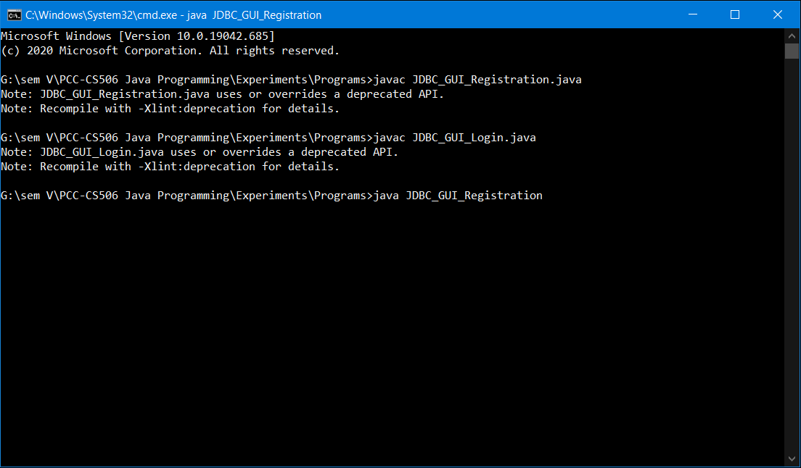

**New User Register Page:**

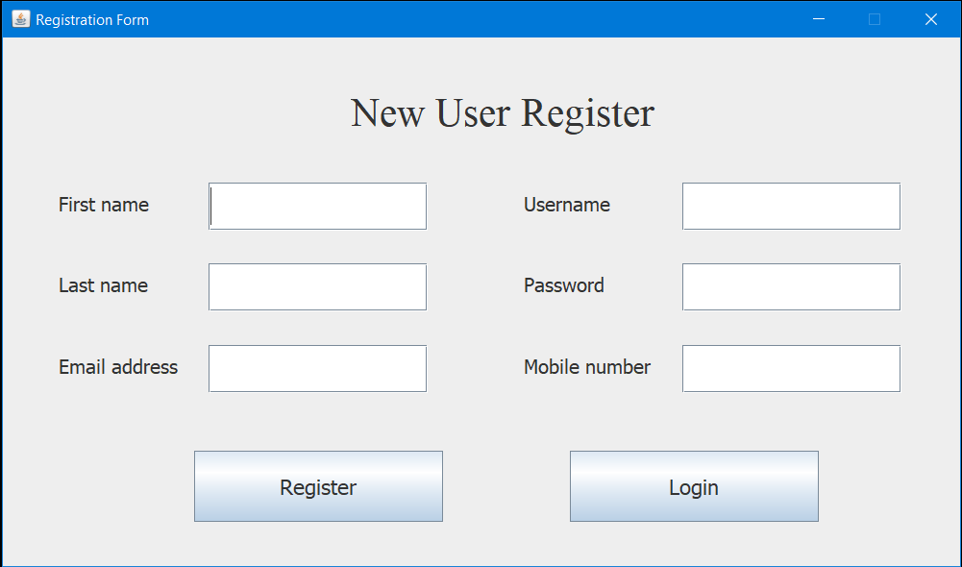

### **Enter User Details in Register Page:**

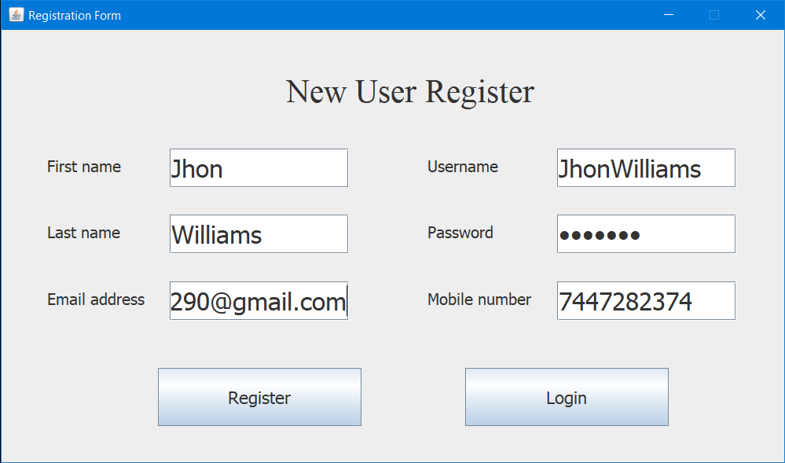

**Successfully User Registration:**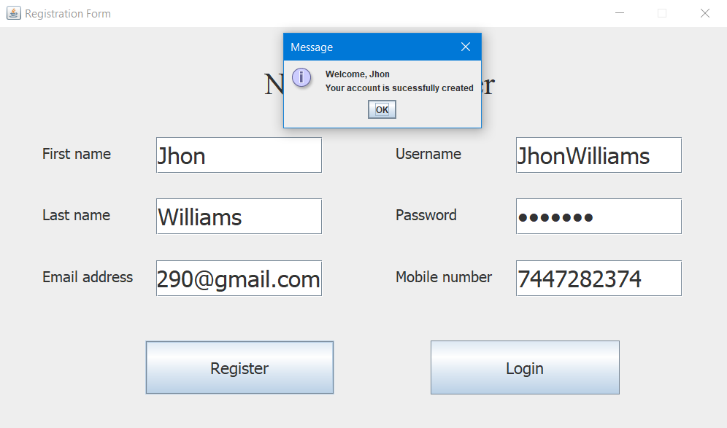

**User Login:**

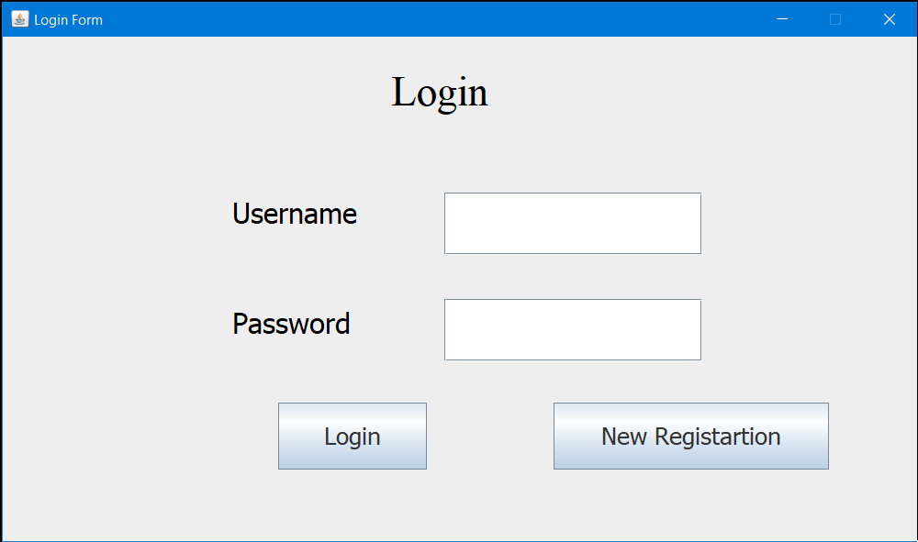

**Successfully User Login:**

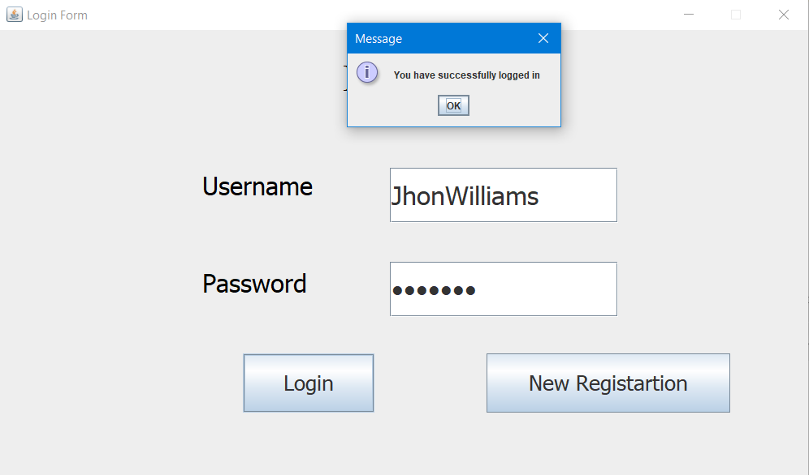

**Data Base:**

